Observer
(Behavioural)

The high-level problem behind the observer pattern is the need for an object to inform another object that a change has occurred.
It’s easier to think about it in terms of subscribing to a newsletter. Every time there’s a new email being sent, it gets delivered to your email account. As long as you remain a subscriber, you get new emails and if you unsubscribe, you stop receiving them. Also, a newsletter can have multiple subscribers, so we have a one-to-many relationship at play.
Here’s the definition from the Head First Design Patterns book:
The Observer Pattern defines a one-to-many dependency between objects so that when one object changes state, all of its dependents are notified and updated automatically.
In software, we call the publisher the subject and the subscribers the observers.
Essentially, when the subject changes its state, it notifies the observers about the change.

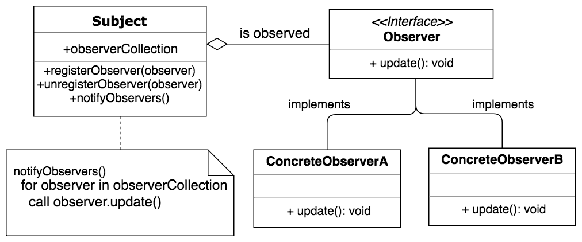

As can be seen in the figure, all concrete observers must implement the Observer interface. The interface has one method that is called by the subject to notify the observers about a state change.
Each subject maintains a list of registered observers and calls the notifyObservers method to inform these observers about any updates or state changes. The subject also has methods for registering and unregistering observers.

Pros
- loose coupling – subject only knows that an observer implements the Observer interface, without concerns for concrete implementations.
- flexibility – can dynamically register and unregister observers.

Cons
- observers are notified in random order.

Step 1
import java.util.ArrayList;
import java.util.List;
import java.util.Observable;

public class Blog extends Observable {
private List<Observer> subscribers = new ArrayList<>();

public void addBlogPost(String blogPostTitle) {
notifyObservers(blogPostTitle);
}

public void notifyObservers(String blogPostTitle) {
for (Observer subscriber : subscribers) {
subscriber.update(this, blogPostTitle);
}
}

public void registerObserver(Observer newSubscriber) {
this.subscribers.add(newSubscriber);
}

public void removeObserver(Observer previousSubscriber) {
this.subscribers.remove(previousSubscriber);
}
}

Step 2
import java.util.Observable;
import java.util.Observer;

public class Subscriber implements Observer {

@Override
public void update(Observable blog, Object blogPostTitle) {
System.out.println( (String)blogPostTitle );
}
}

Step 3
public class ObserverPatternDemo {
public static void main(String[] args) {
// Create the observer and subject.
Blog myBlog = new Blog();
Subscriber subscriber = new Subscriber();

// Register the observer with the subject.
myBlog.registerObserver(subscriber);

// Add some blog post titles.
myBlog.addBlogPost("Docker in 5 Steps");
myBlog.addBlogPost("Angular vs React");
}
}

Step 4 (output)
Docker in 5 Steps
Angular vs React

Observable Interface Deprecated in Java 9
The Observable interface has been deprecated since Java 9. As pointed out in this StackOverflow answer, a few reasons for why it’s been deprecated are as follows:
- not thread-safe – the methods can be overridden by its subclasses, which disrupts thread safety.
- not serializable – the Observable class couldn’t be serialized as it didn’t implement the Serializable interface and all of its members were private.
- poor event model – we don’t know what has changed, just that something has changed (more info).
So what’s the alternative to Observable?
We can use the PropertyChangeListener interface from the java.beans package instead.

Step 1
public class PCLBlog {
private String blogPostTitle;

private PropertyChangeSupport support;

public PCLBlog() {
support = new PropertyChangeSupport(this);
}

public void addPropertyChangeListener(PropertyChangeListener pcl) {
support.addPropertyChangeListener(pcl);
}

public void removePropertyChangeListener(PropertyChangeListener pcl) {
support.removePropertyChangeListener(pcl);
}

public void setBlogPostTitle(String value) {
support.firePropertyChange("blogPostTitle", this.blogPostTitle, value);
this.blogPostTitle = value;
}
}

Step 2
public class PCLSubscriber implements PropertyChangeListener {
private String blogPostTitle;

@Override
public void propertyChange(PropertyChangeEvent evt) {
this.setBlogPostTitle((String) evt.getNewValue());
}
}

Step 3
PCLBlog observable = new PCLBlog();
PCLSubscriber observer = new PCLSubscriber();

observable.addPropertyChangeListener(observer);
observable.setBlogPostTitle("Example Title");
Resources:
https://dragonprogrammer.com/design-patterns-java-observer-pattern/

